**Deploying a Multi-Tier Web Application on Kubernetes**

**Prerequisites**

Before starting, ensure you have the following installed:

* Kubernetes Cluster (Minikube/Kubeadm)
* Docker
* kubectl CLI

**Folder Structure & File Usages**

k8s-project/

│── mysql/ # MySQL Database Configuration

│ ├── mysql-pv.yaml # Persistent Volume for MySQL Data Storage

│ ├── mysql-secret.yaml # Stores MySQL Root Password Securely

│ ├── mysql-deployment.yaml # Deploys MySQL Database as a StatefulSet

│── flask/ # Flask Backend Configuration

│ ├── app.py # Flask API Code to Handle Requests

│ ├── Dockerfile # Flask App Containerization Instructions

│ ├── requirements.txt # Dependencies for Flask

│ ├── flask-deployment.yaml # Deploys Flask Application

│ ├── flask-service.yaml # Exposes Flask App as a Cluster Service

│── nginx/ # Nginx Configuration

│ ├── nginx-configmap.yaml # Reverse Proxy Configuration for Flask

│ ├── nginx-deployment.yaml # Deploys Nginx

│ ├── nginx-service.yaml # Exposes Nginx via NodePort

**Step-by-Step Deployment Guide**

**Step 1: Build and Push Docker Image**

**1.1 Navigate to the Flask directory**

cd flask

**1.2 Build the Docker image**

docker build -t dockerhub_username/flaskapp .

*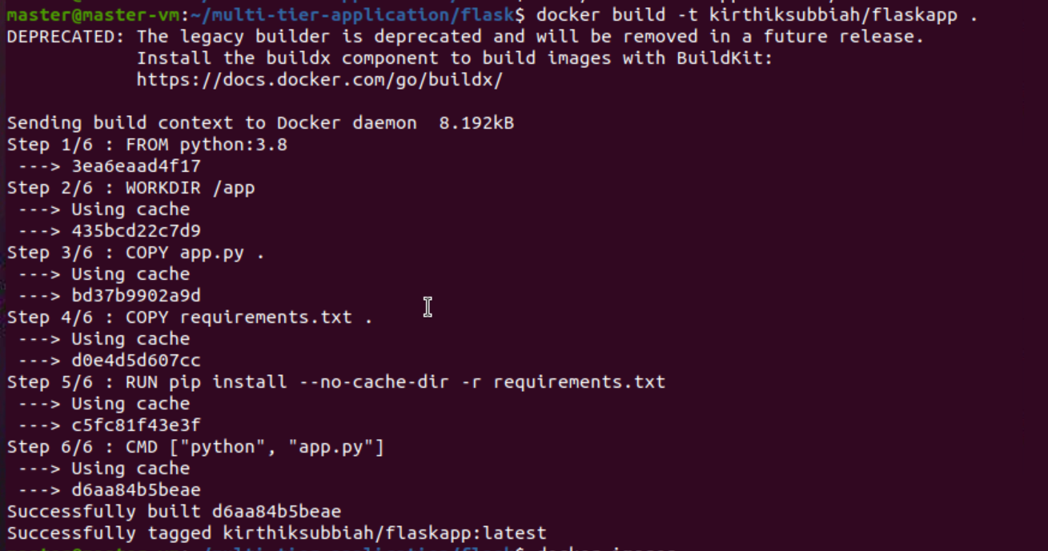***1.3 Push the image to Docker Hub**

docker push dockerhub_username/flaskapp

*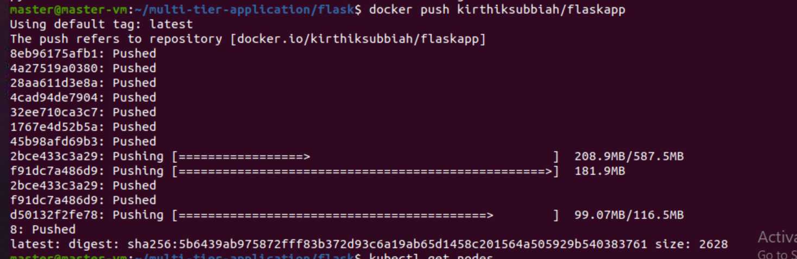***Step 2: Apply Kubernetes Configurations**

**2.1 Deploy Flask application**

kubectl apply -f flask-deployment.yaml

kubectl apply -f flask-service.yaml

*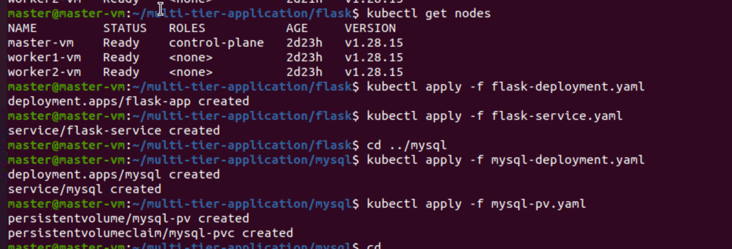***2.2 Deploy MySQL database**

cd ../mysql

kubectl apply -f mysql-deployment.yaml

kubectl apply -f mysql-pv.yaml

kubectl apply -f mysql-secret.yaml

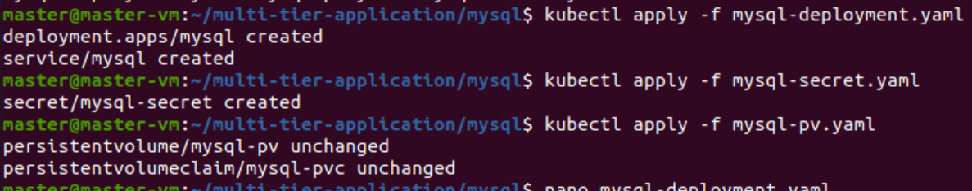

**2.3 Deploy Nginx**

cd ../nginx

kubectl apply -f nginx-configmap.yaml

kubectl apply -f nginx-deployment.yaml

kubectl apply -f nginx-service.yaml

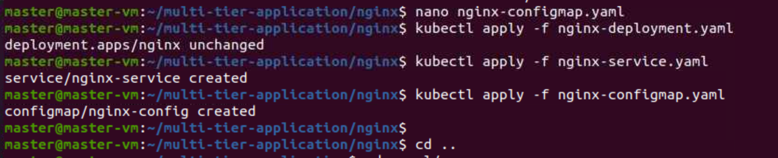

**Step 5: Initialize MySQL Database**

**5.1 Access MySQL inside the Pod**

kubectl exec -it mysql-0 -- mysql -u root -p

*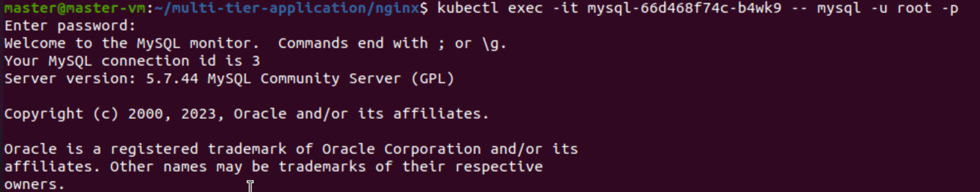***5.2 Create and populate the database**

CREATE DATABASE mydb;

USE mydb;

CREATE TABLE users (

id INT AUTO_INCREMENT PRIMARY KEY,

name VARCHAR(100),

email VARCHAR(100)

);

INSERT INTO users (name, email) VALUES ('Alice', 'alice@example.com');

INSERT INTO users (name, email) VALUES ('Bob', 'bob@example.com');

SELECT * FROM users;

GRANT ALL PRIVILEGES ON mydb.* TO 'user'@'%';

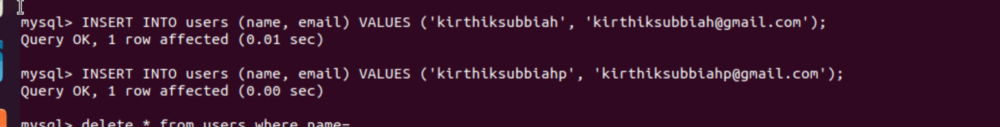

FLUSH PRIVILEGES;

 